Constructing Simple Star Shape

Definition
# Source: AI Source: Provided by: [Data Path: Persons Table -> ID Column: 1, Name_En Column: Motasem Essam] -> From: [ChatGPT] on [7/25/2026]
A simple star shape is a geometric figure with alternating outward vertices and inward vertices, forming a star-like boundary.
A simple star shape has:
- outward-pointing vertices;
- inward-pointing vertices;
- connected boundary edges;
- a non-self-intersecting boundary.
Thus, according to the note:
$$\boxed{\text{Simple Star Shape}=\text{Star-like shape with inward and outward vertices and no boundary crossings}}$$
The boundary may be concave, because the inward vertices create reflex interior angles.

Fundamental Concept
# Source: AI Source: Provided by: [Data Path: Persons Table -> ID Column: 1, Name_En Column: Motasem Essam] -> From: [ChatGPT] on [7/25/2026]
A simple star shape can be constructed by arranging vertices around a common center and alternating between two radial distances.
For example:
- $R$= distance from the center to an outward vertex;
- $r$= distance from the center to an inward vertex.
For a star with $n$outward vertices, there are normally:
$$\boxed{2n}$$
total vertices.
For a five-point simple star:
$$\boxed{5\text{ outward vertices}+5\text{ inward vertices}=10\text{ vertices}}$$
The vertices alternate:
$$O_{1},I_{1},O_{2},I_{2},O_{3},I_{3},…$$
where $O$represents an outward vertex and $I$represents an inward vertex.

Basic Construction Principle
# Source: AI Source: Provided by: [Data Path: Persons Table -> ID Column: 1, Name_En Column: Motasem Essam] -> From: [ChatGPT] on [7/25/2026]
The simplest systematic construction uses two concentric circles.
Let:
- $O$be the common center;
- $R$be the outer radius;
- $r$be the inner radius, where:
$$0<r<R$$
The outer circle determines the outward vertices, while the inner circle determines the inward vertices.
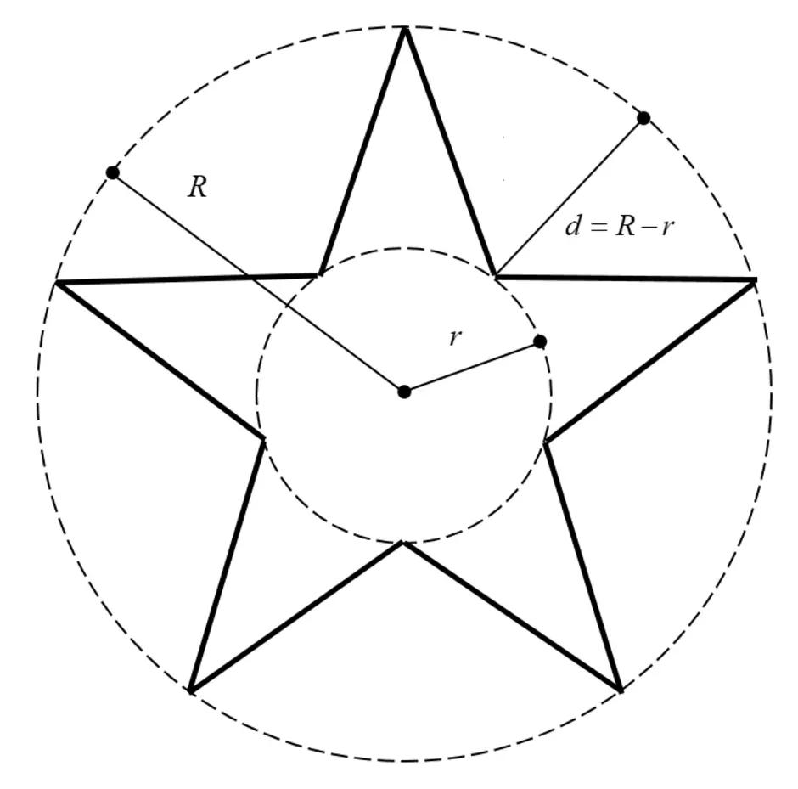
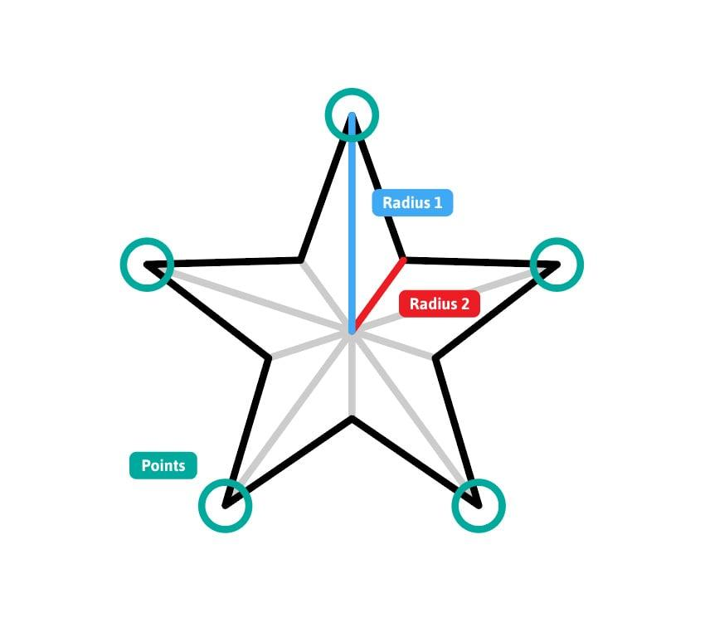
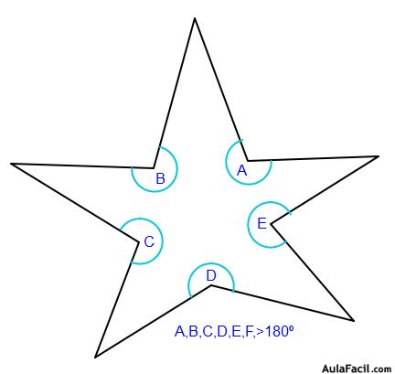
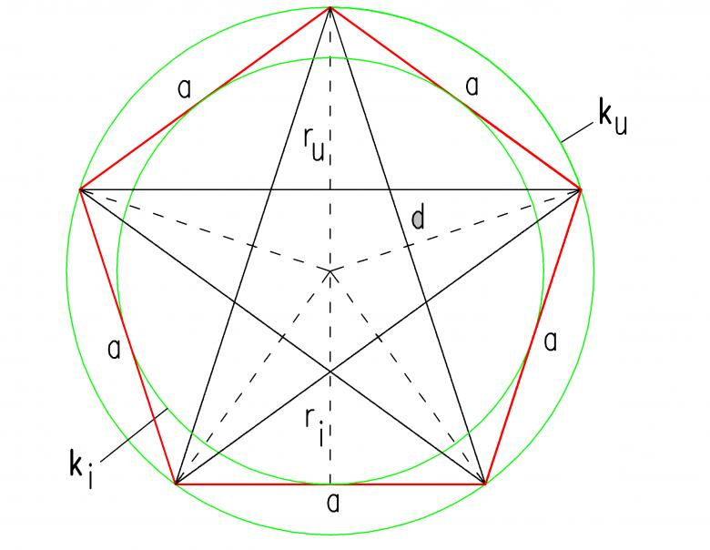

Constructing a Simple Five-Point Star Shape
# Source: AI Source: Provided by: [Data Path: Persons Table -> ID Column: 1, Name_En Column: Motasem Essam] -> From: [ChatGPT] on [7/25/2026]
Step 1: Construct the Outer Circle
Mark a center $O$.
Draw a circle with radius $R$.
This circle determines the positions of the five outward vertices.

Step 2: Construct the Inner Circle
Using the same center $O$, draw a second circle with radius $r$, where:
$$0<r<R$$
This circle determines the positions of the five inward vertices.

Step 3: Divide the Circle Into Ten Equal Angular Positions
A five-point star has ten alternating vertices.
Therefore, divide the full angle around the center into ten equal parts:
$$\boxed{\frac{{360}^{∘}}{10}={36}^{∘}}$$
The angular separation between consecutive vertices is therefore:
$$\boxed{{36}^{∘}}$$

Step 4: Mark the Vertices
Alternately mark points on the two circles.
The sequence is:
$$O_{1},I_{1},O_{2},I_{2},O_{3},I_{3},O_{4},I_{4},O_{5},I_{5}$$
where:
- $O_{1},…,O_{5}$lie on the outer circle;
- $I_{1},…,I_{5}$lie on the inner circle.
Thus:
$$OO_{i}=R$$
and:
$$OI_{i}=r$$

Step 5: Connect Consecutive Vertices
Connect the vertices in their circular order:
$$O_{1}→I_{1}→O_{2}→I_{2}→O_{3}→I_{3}→O_{4}→I_{4}→O_{5}→I_{5}→O_{1}$$
This creates the simple star boundary.

Why the Boundary Does Not Cross Itself
# Source: AI Source: Provided by: [Data Path: Persons Table -> ID Column: 1, Name_En Column: Motasem Essam] -> From: [ChatGPT] on [7/25/2026]
The vertices are connected in circular order.
Each edge connects two consecutive vertices around the boundary.
Therefore, the edges remain between neighboring angular positions rather than jumping across the interior of the shape.
The essential rule is:
$$\boxed{\text{Connect consecutive vertices in circular order}}$$
This produces a simple polygon rather than a self-intersecting star polygon.

Mathematical Representation
# Source: AI Source: Provided by: [Data Path: Persons Table -> ID Column: 1, Name_En Column: Motasem Essam] -> From: [ChatGPT] on [7/25/2026]
For a regular five-point construction, the vertices can be represented using polar coordinates.
Let:
$$θ_{k}={36}^{∘}k$$
for:
$$k=0,1,…,9$$
The radial distance alternates between $R$and $r$:
$$ρ_{k}=\left\{\begin{matrix}R, & k\text{ even} \\ r, & k\text{ odd}\end{matrix}\right.$$
Therefore, the Cartesian coordinates are:
$$\boxed{x_{k}=ρ_{k}\cos{θ_{k}}} \\ \boxed{y_{k}=ρ_{k}\sin{θ_{k}}}$$
This produces alternating outward and inward vertices.

Fundamental Properties
# Source: AI Source: Provided by: [Data Path: Persons Table -> ID Column: 1, Name_En Column: Motasem Essam] -> From: [ChatGPT] on [7/25/2026]
A simple star shape constructed in this way has:
Alternating Vertices
$$\boxed{\text{Outward}→\text{Inward}→\text{Outward}→\text{Inward}→⋯}$$
Concave Boundary
The inward vertices produce reflex interior angles.
Therefore, a typical simple star shape is a:
$$\boxed{\text{Concave Simple Polygon}}$$
Non-Self-Intersecting Boundary
No two nonconsecutive boundary edges cross.
Therefore:
$$\boxed{\text{Simple Star Shape}⊂\text{Simple Polygon}}$$
when the star shape is represented as a polygonal boundary.
Closed Boundary
The final vertex is connected back to the first vertex.
Thus the boundary forms a closed polygon.

Outward and Inward Vertices
# Source: AI Source: Provided by: [Data Path: Persons Table -> ID Column: 1, Name_En Column: Motasem Essam] -> From: [ChatGPT] on [7/25/2026]
Outward Vertex
An outward vertex points away from the center of the star.
Its distance from the center is:
$$\boxed{R}$$

Inward Vertex
An inward vertex points toward the center relative to the neighboring outward vertices.
Its distance from the center is:
$$\boxed{r}$$
where:
$$r<R$$

Types / Construction Situations
# Source: AI Source: Provided by: [Data Path: Persons Table -> ID Column: 1, Name_En Column: Motasem Essam] -> From: [ChatGPT] on [7/25/2026]
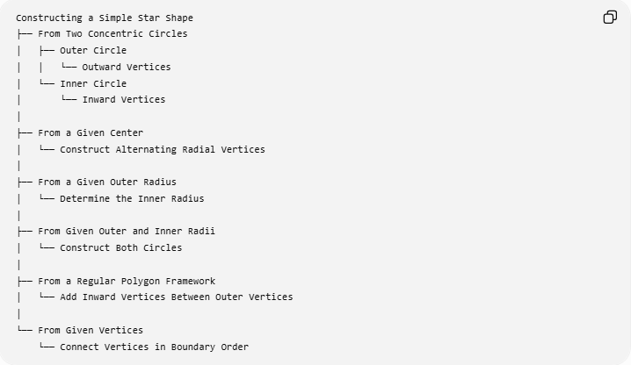
Constructing a Simple Star Shape
├── From Two Concentric Circles
│ ├── Outer Circle
│ │ └── Outward Vertices
│ └── Inner Circle
│ └── Inward Vertices
│
├── From a Given Center
│ └── Construct Alternating Radial Vertices
│
├── From a Given Outer Radius
│ └── Determine the Inner Radius
│
├── From Given Outer and Inner Radii
│ └── Construct Both Circles
│
├── From a Regular Polygon Framework
│ └── Add Inward Vertices Between Outer Vertices
│
└── From Given Vertices
└── Connect Vertices in Boundary Order
Classification note: these are construction situations rather than universally standardized mathematical types of simple star shapes.

Construction by Number of Points
# Source: AI Source: Provided by: [Data Path: Persons Table -> ID Column: 1, Name_En Column: Motasem Essam] -> From: [ChatGPT] on [7/25/2026]
A simple star can have different numbers of outward points.
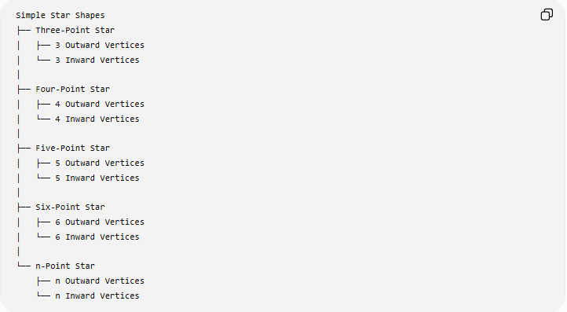
Simple Star Shapes
├── Three-Point Star
│ ├── 3 Outward Vertices
│ └── 3 Inward Vertices
│
├── Four-Point Star
│ ├── 4 Outward Vertices
│ └── 4 Inward Vertices
│
├── Five-Point Star
│ ├── 5 Outward Vertices
│ └── 5 Inward Vertices
│
├── Six-Point Star
│ ├── 6 Outward Vertices
│ └── 6 Inward Vertices
│
└── n-Point Star
├── n Outward Vertices
└── n Inward Vertices
For an $n$-point alternating star:
$$\boxed{\text{Total Vertices}=2n}$$
and the angular separation between consecutive vertices is:
$$\boxed{\frac{{360}^{∘}}{2n}=\frac{{180}^{∘}}{n}}$$

Regular and Irregular Simple Star Shapes
# Source: AI Source: Provided by: [Data Path: Persons Table -> ID Column: 1, Name_En Column: Motasem Essam] -> From: [ChatGPT] on [7/25/2026]
Regular Simple Star Shape
A simple star can have rotational symmetry when the outward and inward vertices are evenly distributed around the center.
For a regular five-point construction:
$$\boxed{{36}^{∘}}$$
separates every consecutive vertex.
If the radial distances $R$and $r$remain constant throughout the construction, the star has rotational symmetry.

Irregular Simple Star Shape
A simple star can also have:
- unequal outer radii;
- unequal inner radii;
- unequal angular spacing;
- different point lengths;
- different point shapes.
The important condition from your definition remains:
$$\boxed{\text{The boundary does not cross itself}}$$

Simple Star Shape vs Self-Intersecting Star Polygon
# Source: AI Source: Provided by: [Data Path: Persons Table -> ID Column: 1, Name_En Column: Motasem Essam] -> From: [ChatGPT] on [7/25/2026]
This distinction is important.
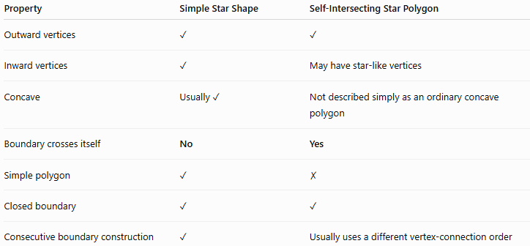
Property | Simple Star Shape | Self-Intersecting Star Polygon
Outward vertices | ✓ | ✓
Inward vertices | ✓ | May have star-like vertices
Concave | Usually ✓ | Not described simply as an ordinary concave polygon
Boundary crosses itself | No | Yes
Simple polygon | ✓ | ✗
Closed boundary | ✓ | ✓
Consecutive boundary construction | ✓ | Usually uses a different vertex-connection order
A simple star shape therefore should not be confused with a self-intersecting star polygon such as a pentagram.

Simple Star Shape vs Regular Polygon
# Source: AI Source: Provided by: [Data Path: Persons Table -> ID Column: 1, Name_En Column: Motasem Essam] -> From: [ChatGPT] on [7/25/2026]
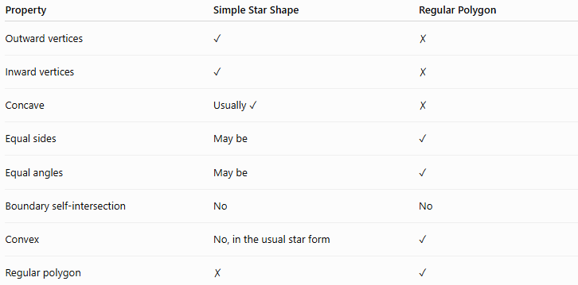
Property | Simple Star Shape | Regular Polygon
Outward vertices | ✓ | ✗
Inward vertices | ✓ | ✗
Concave | Usually ✓ | ✗
Equal sides | May be | ✓
Equal angles | May be | ✓
Boundary self-intersection | No | No
Convex | No, in the usual star form | ✓
Regular polygon | ✗ | ✓
A simple star shape is therefore generally concave, while a regular polygon is convex.

Geometric Construction Tools
# Source: AI Source: Provided by: [Data Path: Persons Table -> ID Column: 1, Name_En Column: Motasem Essam] -> From: [ChatGPT] on [7/25/2026]
The main tools are:
Straightedge
Used to:
- draw the boundary edges;
- draw construction lines;
- connect vertices.
Compass
Used to:
- construct the outer circle;
- construct the inner circle;
- transfer equal distances;
- locate points at specified radii.
Protractor
A protractor can be used for practical constructions when measuring the required central angles, although classical straightedge-and-compass construction is preferred for exact geometric constructions.

Basic Constructions Used
# Source: AI Source: Provided by: [Data Path: Persons Table -> ID Column: 1, Name_En Column: Motasem Essam] -> From: [ChatGPT] on [7/25/2026]
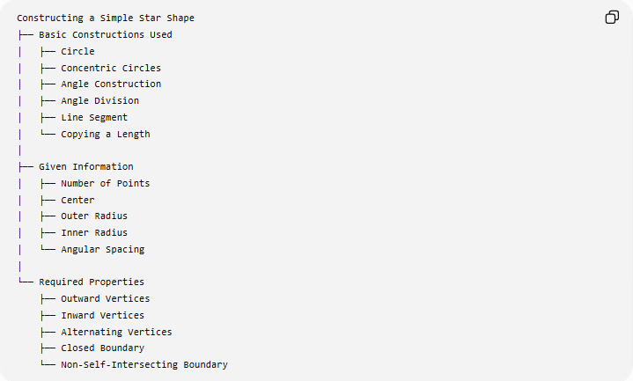
Constructing a Simple Star Shape
├── Basic Constructions Used
│ ├── Circle
│ ├── Concentric Circles
│ ├── Angle Construction
│ ├── Angle Division
│ ├── Line Segment
│ └── Copying a Length
│
├── Given Information
│ ├── Number of Points
│ ├── Center
│ ├── Outer Radius
│ ├── Inner Radius
│ └── Angular Spacing
│
└── Required Properties
├── Outward Vertices
├── Inward Vertices
├── Alternating Vertices
├── Closed Boundary
└── Non-Self-Intersecting Boundary

Classification in Geometric Construction
# Source: AI Source: Provided by: [Data Path: Persons Table -> ID Column: 1, Name_En Column: Motasem Essam] -> From: [ChatGPT] on [7/25/2026]
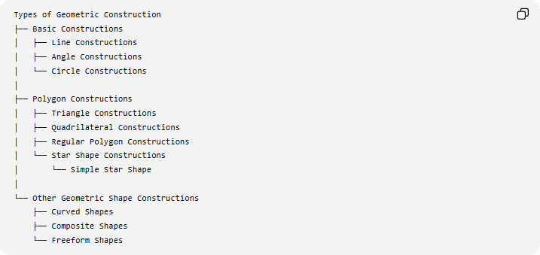
Types of Geometric Construction
├── Basic Constructions
│ ├── Line Constructions
│ ├── Angle Constructions
│ └── Circle Constructions
│
├── Polygon Constructions
│ ├── Triangle Constructions
│ ├── Quadrilateral Constructions
│ ├── Regular Polygon Constructions
│ └── Star Shape Constructions
│ └── Simple Star Shape
│
└── Other Geometric Shape Constructions
├── Curved Shapes
├── Composite Shapes
└── Freeform Shapes
Classification note: “Star Shape Constructions” is a useful descriptive construction category. A simple star shape is defined here by its alternating inward/outward vertices and its non-self-intersecting boundary, rather than by a single universally standardized polygon classification.

Key Points
# Source: AI Source: Provided by: [Data Path: Persons Table -> ID Column: 1, Name_En Column: Motasem Essam] -> From: [ChatGPT] on [7/25/2026]
- A simple star shape has both outward and inward vertices.
- Its boundary does not cross itself.
- A typical simple star shape is a concave simple polygon.
- A convenient construction uses two concentric circles.
- Outward vertices lie on the outer circle.
- Inward vertices lie on the inner circle.
- The vertices are connected in circular order.
- For an $n$-point star:
$$\boxed{\text{Total Vertices}=2n}$$
- The angular separation between consecutive vertices in an evenly spaced construction is:
$$\boxed{\frac{{180}^{∘}}{n}}$$
- A five-point star has:
$$\boxed{10\text{ vertices}}$$
and:
$$\boxed{{36}^{∘}}$$
between consecutive vertices.
- A simple star shape should be distinguished from a self-intersecting star polygon.

Conclusion
# Source: AI Source: Provided by: [Data Path: Persons Table -> ID Column: 1, Name_En Column: Motasem Essam] -> From: [ChatGPT] on [7/25/2026]
A simple star shape is a concave, star-like geometric figure whose boundary alternates between outward and inward vertices without crossing itself. It can be systematically constructed by using two concentric circles, dividing the full angle around the center into equal parts, alternating vertices between the outer and inner circles, and connecting consecutive vertices in circular order. This construction guarantees a closed, non-self-intersecting star boundary when the vertices are positioned appropriately.

